Hülya İlhan - Aslı Mustafa Takmaklı Kızılay Anaokulu Nazilli Aydın Turkey

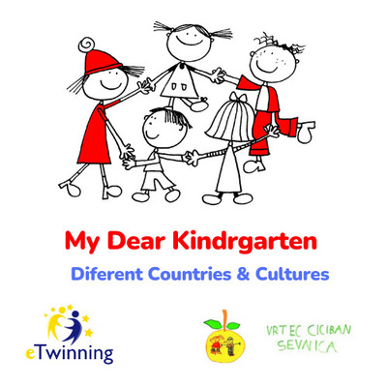

Bernarda From Kindergarten Sevnica, Slovenija
lOGO

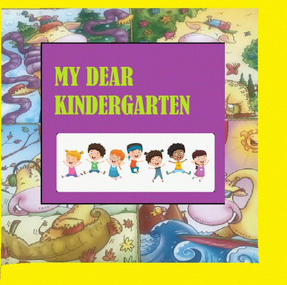

Mein kreative Logo / My creative Logo
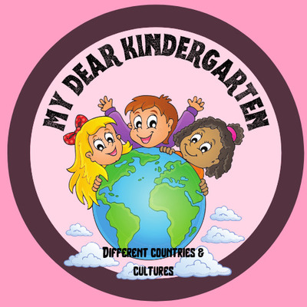

Esra Yiğitalp/SMTAL UYGULAMA ANAOKULU/TURKEY
My Logo
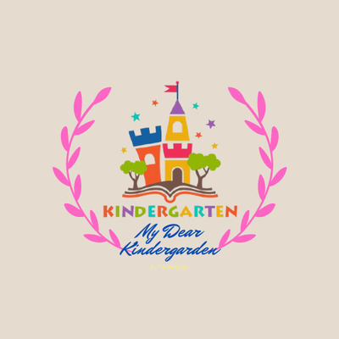

SEDA NUR DEMİRKOL / GAZİ UMURBEY ANAOKULU/İZMİR/TURKEY
MY LOGO
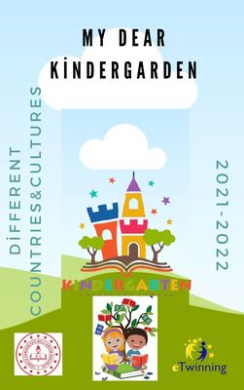

SEDA NUR DEMİRKOL / GAZİ UMURBEY ANAOKULU/İZMİR/TURKEY
MY POSTER
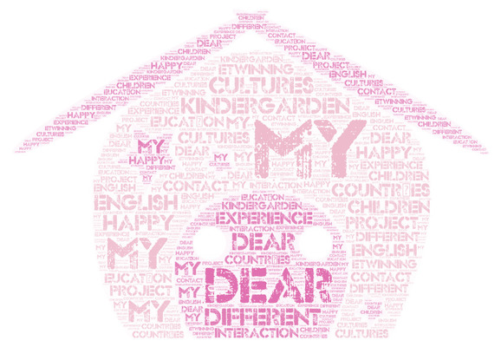

SEDA NUR DEMİRKOL / GAZİ UMURBEY ANAOKULU/İZMİR/TURKEY
MY WORD CLOUD
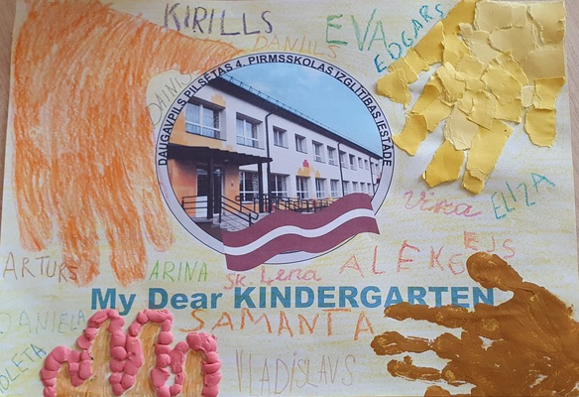

Daugavpils 4.pirmsskolas izglītības iestāde,Latvija
Logo

Logo from Wilamowice, Poland
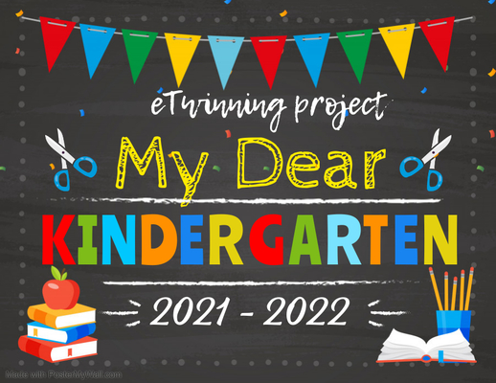

Atanaska Tacheva
my logo

L/D "AŽUOLIUKAS", KLAIPĖDA, LITHUAINIA
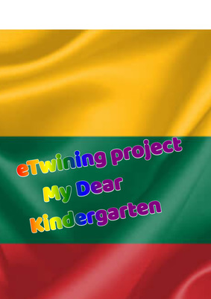

L/d"Ąžuoliukas",Klaipėda, LITHUAINIA
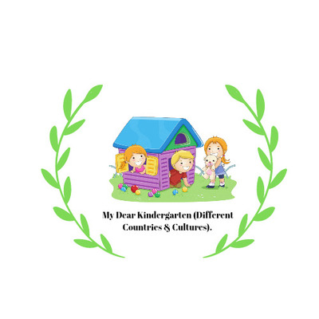

Ülkü ÇAKAR ZÜBEYDE HANİM KİNDERGARTEN / TURKEY
Logo
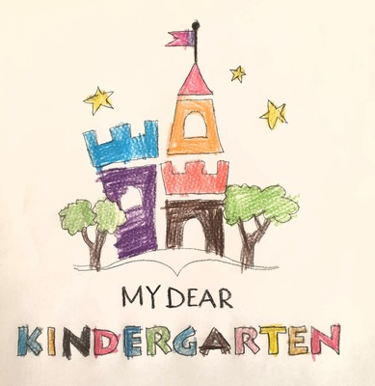

Kindergarten "Pupų pėdas", Šiauliai, Lithuania
Logo
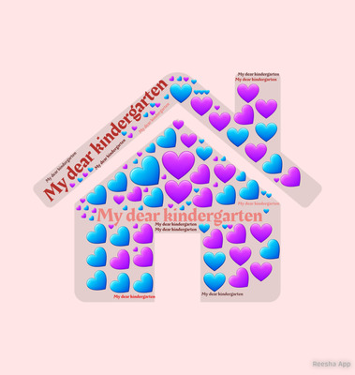

Esra Yiğitalp/SMTAL UYGULAMA ANAOKULU/Turkey
My world cloud

Mine Demir-Elmalı Anaokulu-Antalya / TURKİYE
MY LOGO
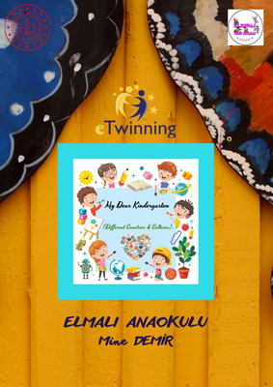

Mine Demir-Elmalı Anaokulu-Antalya / TURKİYE
MY POSTER
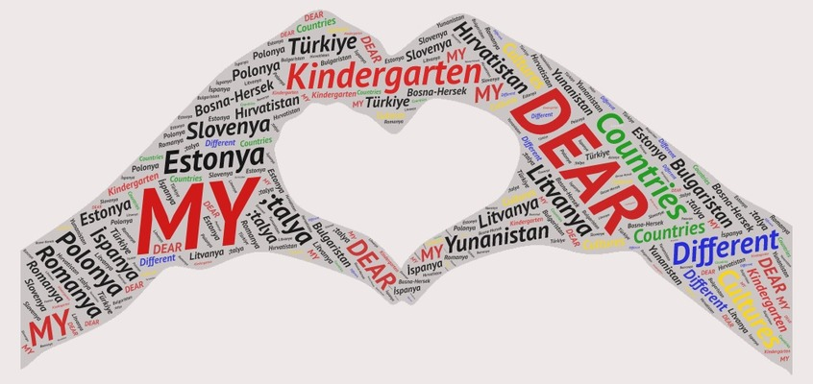

Mine Demir-Elmalı Anaokulu-Antalya / TURKİYE
My world cloud
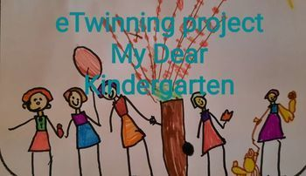

Vilija Stonė, Lietuva. l/d "Ąžuoliukas"
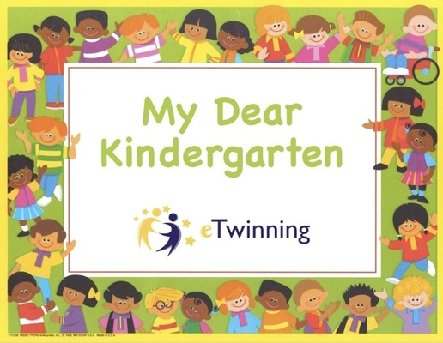

Diyana Icheva
Logo - Kindergarten "Hans Kr. Andersen", Burgas, Bulgaria
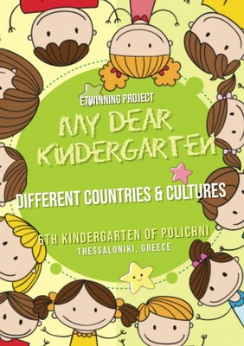

Anastasia Papatziamou, 6th Kindergarten of Polichni, Thessaloniki, Greece
My poster
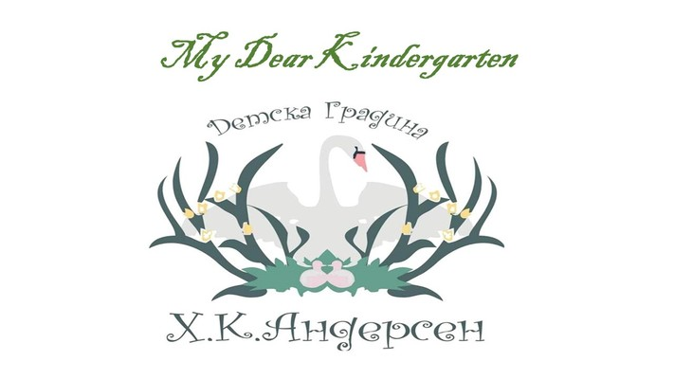

Katia Plachkova-Bulgaria,Burgas
Kundergarten "Andersen"
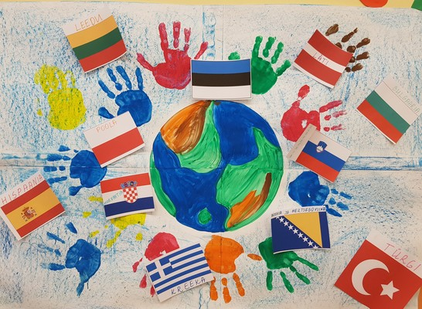

Kindergarten Ojake
Kids made Logo using colors, hands, flags.
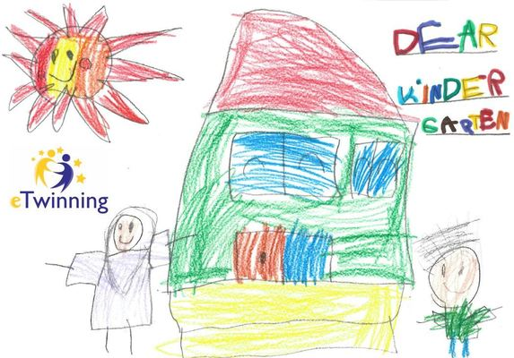

Poster_CEIP Ponce de León
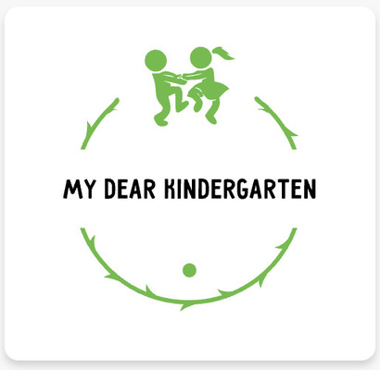

Tallinna Tammetõru Lasteaed. Estonia.

